14.70: a) Let d be the depth of the oil layer, h the depth that the cube is submerged in the water, and L be the length of a side of the cube. Then, setting the buoyant force equal to the weight, canceling the common factors of g and the cross-section area and supressing units,
d. Substitution into the first relation gives 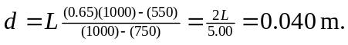 b) The gauge pressure at the lower face must be sufficient to support the block (the oil exerts only sideways forces directly on the block), and As a check, the gauge pressure, found from the depths and densities of the fluids, is

